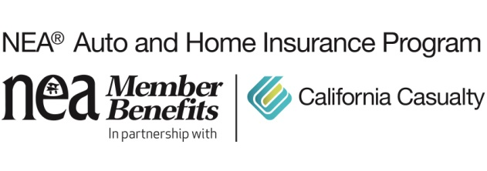
Why Your Rental Car Reimbursement Coverage May Not Be Enough
Anyone who has ever dropped off a kid at soccer practice, then zipped another one over to dance class, and then went back to school for pick-up when practice was over, knows the reality of parenting today. We live in our cars. In fact, we can’t live without them, which is why it’s more than just an inconvenience when our cars are suddenly unavailable.
When a car accident happens that necessitates a car going into the shop for repairs, getting a rental car is often a solution. That’s where rental car reimbursement coverage (also called transportation expense coverage) comes into play. A basic amount of this coverage is included with collision/comprehensive coverage in your auto policy. It helps cover the cost of a rental car after a car accident, but these days the basic coverage may not be enough. Many people are unaware that optional, higher coverage levels are available.
Things are changing—which could impact your budget.
Today’s world is not the same as pre-pandemic. The changes that have occurred in the last couple of years are impacting the car repair and rental car industries. This could cause you to pay significantly more out-of-pocket even with rental car reimbursement. Read on to find out why, and what you can do about it.
Parts are taking longer to get.
We’ve been spoiled with free, fast shipping, getting items in a couple of days from the time we order them. That’s no longer the case. Just as you probably had to wait for the hottest toy for the holidays (or that elusive Sony PlayStation 5), repair shops have had to wait…and wait…and wait…for parts. There’s a global supply chain shortage. Parts that used to arrive in a day or two are now taking weeks or longer. Ships carrying supplies are being held at docks. There’s also a global semiconductor shortage, which especially affects the advanced electronics systems in our cars.
Shops are doing partial repairs or keeping your car indefinitely.
With parts delayed for weeks or longer, some shops are making partial repairs on drivable vehicles, sending them home and finishing the job later. They are keeping undriveable cars for weeks or even months, while waiting for parts.
When there’s no one to work on your car, it sits longer.
The labor shortage has hit the automotive industry. There are fewer truck drivers transporting parts, fewer dock workers unloading them, and fewer mechanics working. The pandemic prompted many people to reevaluate their career choices and leave their jobs. If you’re lucky, your repair hop is fully staffed. If not, you’re likely in for a longer time for your car to be fixed.
Your car could be in the shop longer than your rental coverage.
Normally, you’d expect to have a rental car for a couple of weeks. It might surprise you to learn that the average repair time at the end of last year was 17 days, according to Enterprise Rent-A-Car. That means many people had their cars in the shop even longer than that. The length of car rentals has continued to increase in 2022. If shops are waiting on parts and workers, chances are your rental car coverage will run out before repairs are completed. Not only that, but the rental bill could even be more than the repair bill, resulting in being hit with an expense that insurance doesn’t fully cover.
Rental cars are getting more expensive.
Longer collision repair times are just part of higher costs. Rising inflation rates and greater demand for vehicles have increased rental car prices. AAA is seeing car rental prices trending higher in 2022 than in the previous four years.
It makes sense (and cents) to bump up your coverage.
The typical auto policy includes a basic amount of coverage that reimburses up to $20 a day with a $600 cap per accident. That means your $20 per day coverage lasts for 30 days. Luckily, you’re not limited to those numbers. Consider expanding your daily/per accident coverage limits to $30/$900, $40/$1,200 or $50/$1,500. Be sure you’re not having to spend more out-of-pocket due to today’s higher cost of rental cars and, especially, longer car repair times.

California Casualty has been serving the needs of educators since 1951 and is the only auto and home insurance company to earn the trust and endorsement of the National Education Association (NEA). Learn how to save on your insurance by getting a quote at www.neamb.com/autohome, or by calling 1.800.800.9410.

