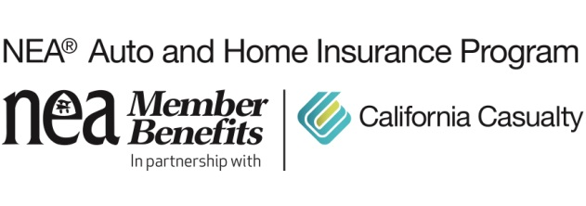
If You “Put a Ring on It”, Insure It

February is the month of love. If you choose to show your love with an expensive piece of jewelry, you’ll want to protect that enduring representation of your love.

One of the best ways is to purchase scheduled personal property (SPP) insurance, sometimes called a floater.

Here’s why: While your renters or homeowner’s insurance policy covers jewelry for theft or being destroyed in a fire, that coverage is limited. The average Valentine’s Day ring or necklace purchase is about $1,500, the average spend for an engagement ring is $6,000.

Scheduled personal property insurance provides higher coverage for your precious items, like high priced jewelry with coverage above and beyond what home insurance provides.

And, here’s the best part, SPP pays even if that prized piece was accidentally lost or damaged – such as losing a diamond down the sink or toilet. There is no deducible and SPP provides a replacement at the full insured amount. SPP usually costs about one to two percent of the item’s value.

Scheduled personal property isn’t just for jewelry; you might need the endorsement if you have:

- Fine art
- Furs
- Rare coins or money collections
- Expensive cameras
- Firearms
- Fine silverware
- Stamp collections

And even if you already have gold and jewelry or a rare watch covered with scheduled personal property coverage, you may need a review. Gold and diamond prices have climbed the past few years and you may not have enough protection for their new value.

Don’t wait until your precious items are lost, stolen or damaged to find out if you have enough coverage to replace them; contact a representative today.

California Casualty has been serving the needs of educators since 1951 and is the only auto and home insurance company to earn the trust and endorsement of the National Education Association (NEA). As a result, NEA members qualify for exceptional rates, deductibles waived for vandalism or collisions to your vehicle parked at school, holiday or summer skip payment plans and free Identity Defense protection – exclusive benefits not available to the general public. Learn how to save by getting a quote at www.calcas.com/neamb, or by calling 1.800.800.9410.

